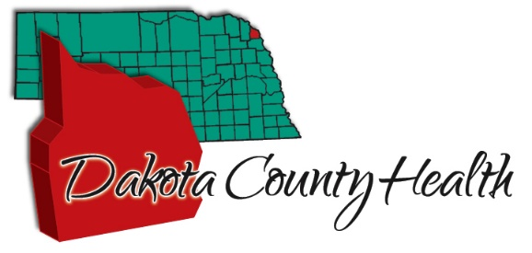
PO Box 155
1601 Broadway
Dakota City, NE 68731
Phone: 402-987-2164
Fax: 402-987-2163
Email: HealthDeptPIO@dakotacountyne.org
Dakota County Health Department
Client Intake/ Release of Information Form
No VFC child (0-18) will be denied service do inability to pay.

Person Receiving Services: _______________________________________________________________
MI
First Name
Last Name

Address: _____________________________________________________________________________

City: ___________________________________ State: ___________________ Zip: _____________

Date of Birth: ______/______/______ Medicaid Number: ______________________
11-digit code

Phone Number: __________________________

Insurance Plan (Check Below):

Nebraska Medicaid
Healthy Blue
Total Care of NE
United Healthcare-Community Plan

The Dakota County Health Department (DCHD) provides programs on behalf of the Nebraska Department of Health and Human Services (NE DHHS). Also, some DCHD programs bill NE DHHS Medicaid for services provided. If this occurs, the DCHD is a business associate of NE DHHS and we may be required to share health information with these parties for necessary health care operations.

I authorize the release of medical information necessary to bill my designated insurance company, and request payment of benefits to Dakota County Health Department (DCHD).

Responsible Party Signature: _______________________________________________Date:_______________________

